Dear Friends and Family of CAP Theatre,

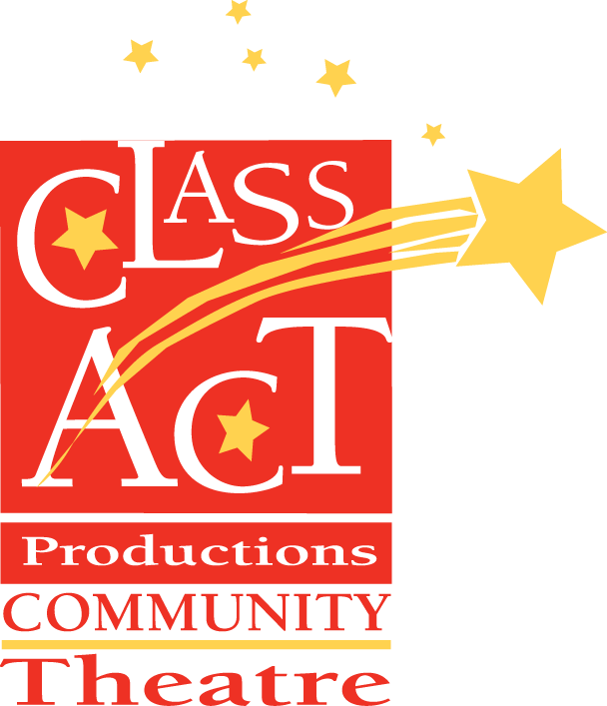

**Theatre for children,**

**Theatre by children.**

**201 1st Ave S**

**Altoona, IA 50009**

**www.captheatre.org**

**info@captheatre.org**

**(515) 967-7950**

As parents, volunteers, board members and staff, our hands-on experience tells us how much time and effort it takes to operate a community theatre. From producing, designing, directing and staging productions, we know there are challenges associated with providing the type of experience that sits at the heart of why we do, what we do. With each donation, sponsorship, volunteer hour and effort that we receive, we wish to express our immense gratitude.

Class Act Productions Community Theatre, as a non-profit organization, relies on community support, donations and sponsorships to be able to secure the equipment and facilities that are necessary to make our mission a success.

There are many opportunities to make a donation. On the second page of this PDF you will find a breakdown of our individual and corporate donations/sponsorships.

For any questions, please email us at info@captheatre.org or leave us a voice mail at 515-967-7950.

Thank you very much for supporting CAP Theatre!

Board of Directors  
Class Act Productions

Please complete the following, select your donation/sponsorship level on page two and mail these along your contribution to our theatre at the address on the upper left:

Name (Individual or Company):

Address:

City, State & Zip:

Telephone:

Email:

□ Please do not add my email address in your CAP newsletter database

By signing below, you are confirming your donation/sponsorship commitment.

Printed Name:

Signature: Date:

If you would like make your contribution/sponsorship using a credit card, please follow the link to our PayPal account from our website and note in the comments which level donation/sponsorship. Thank you!

# Donation Opportunities:

* **Patron ($10-$149):** Your name is listed in the programs for all shows for our current season and included on the pre-show PowerPoint presentation for each show in our season.
* **Actor ($150-$299):** Everything listed for Actor Level, plus you receive a CAP water bottle.
* **Director ($300-$599):** Everything listed for Director Level, plus you receive a CAP t-shirt.
* **Producer ($600 or more):** Everything listed for Producer level. You also 2 complimentary tickets to each mainstage musical performance during the current season.

# Sponsorship Opportunities:

* **Lunch 'N Laughs Sponsor ($300):** Your company name is listed on the placemat, included in CAP Facebook notifications & email newsletters promoting the production, and the pre-show announcements. You receive 2 complimentary tickets to one performance of the production you are sponsoring. (Only one show sponsor allowed per production)
* **CAP Classic Sponsor ($300):** Your company name is listed on the program scroll, included in CAP Facebook notifications & email newsletters promoting the production, and the pre-show announcements. You receive 2 complimentary tickets to one performance of the production you are sponsoring. (Only one show sponsor allowed per production)
* **Costume/Scenery Sponsor for one Mainstage Musical ($500):** Your company name is listed in the program, included in CAP Facebook notifications and the pre-show PowerPoint presentation. You receive 2 complimentary tickets to one performance of the production you are sponsoring. (Only two sponsors allowed per production)
* **Show Sponsor for one Mainstage Musical ($1000):** Your company name is listed on the cover of the program, on all printed materials (posters/flyers), included in CAP Facebook notifications & email newsletters promoting the production, and the pre-show PowerPoint presentation. You receive 4 complimentary tickets for the production you are sponsoring. (Only one show sponsor allowed per production)
* **Class Act Season Sponsor ($5000):** Your company name is listed on the covers of all programs/ placements for every production, on any/all printed materials for each show (posters/flyers), displayed on CAP’s outdoor marquee for the season, included in CAP Facebook notifications & email newsletters promoting the productions, and all pre-show speeches/ PowerPoint presentations. You receive a season total of 12 complimentary tickets to use for any production in the season you are sponsoring. (Only one season sponsor allowed per year – once purchased we also will stop offering the other sponsorships for the season)