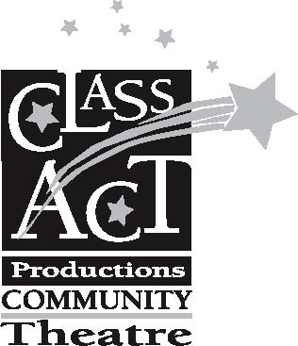 | 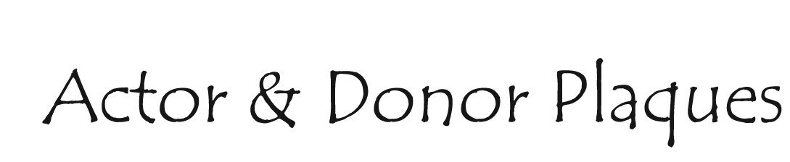
Commemorate your favorite actor’s performance,
or your own donation with a permanent place at CAP Theatre.

Contact Information:
Your name: _________________________________________________________________________
Address: ___________________________________________________________________________
State: _________________________ Zip: _______________ Phone: ___________________________

Message (see below for the number of lines on your plaque):
Line (1): ____________________________________________________________________________
Line (2): ____________________________________________________________________________
Line (3): ____________________________________________________________________________
Line (4): ____________________________________________________________________________

ACTOR/BOARD PLAQUE | PRICE | AMOUNT
Plaque (4 lines, 20 characters per line) | $100.00
DONOR PLAQUE | PRICE | AMOUNT
Donor Recognition (2 lines) | $300.00
Star Donor Recognition (4 lines) | $600.00

GRAND TOTAL

• Actor Plaques will be featured on CAP’s marquee wall reserved for special recognition of cast & board members only.
• Donor plaques will be featured in a dedicated section of CAP’s wall.

Donations will go to the general fund of CAP Theatre to help us fulfill our mission to give young people, regardless of experience, the opportunity to be part of and appreciate live theatre. If you would like a portion of your donation to be earmarked specifically for the CAP Scholarship fund please let us know.

